Planning and Environment Act 1987

HUME PLANNING SCHEME

AMENDMENT C269

draft PLANNING PERMITs PA2302140, PA2302142 AND PA2302143

EXPLANATORY REPORT

Who is the planning authority?
This amendment has been prepared by the Minister for Planning, who is the planning authority for this amendment.
The amendment has been made at the request of MAB Corporation Pty Ltd.

Land affected by the amendment
The amendment applies to 140-204 Western Avenue, Westmeadows, as shown in the map below.
The land comprises Lots 1 & 2 on TP512682 (2 parcels) and is approximately 29 hectares in area. The site boundaries are defined by Tullamarine Freeway to the south, Wright Street to the east, Victoria Street to the west (unformed) and the Moonee Ponds Creek to the north. Western Avenue separates the southern portion of the land from the balance of the subject site.
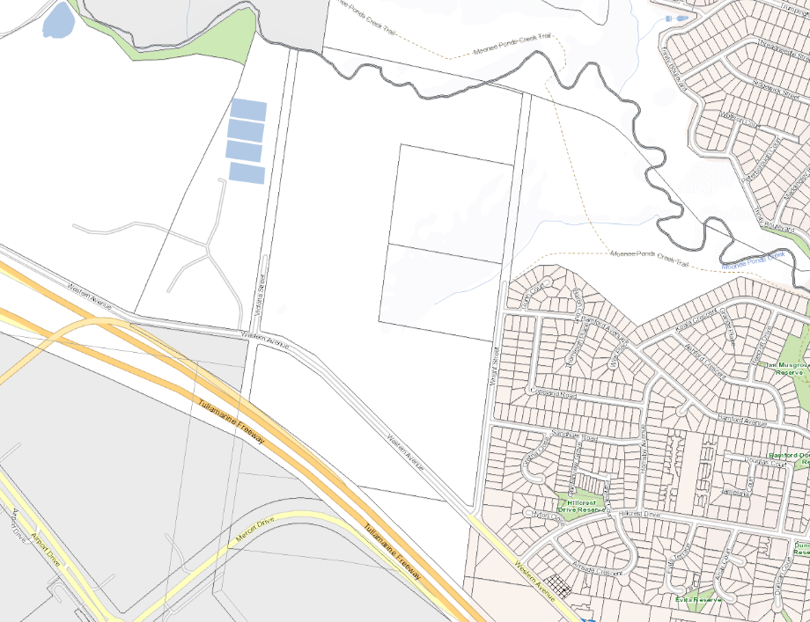

[Insert if large number of maps are being inserted, amended or deleted.

The amendment is a combined planning permit application and planning scheme amendment under section 96A of the Act.
The draft planning permits apply to 140-204 Western Avenue, Westmeadows and seek approval, via three separate planning permits for:
- Staged multi lot subdivision, construction and use of a Utility installation, removal of native vegetation and part removal of a drystone wall in accordance with endorsed plans
- Staged development of the land for use as warehouse, construction and display of advertising signs and a reduction in the car parking requirements generally in accordance with the endorsed plans
- Use and development of the land for a utility installation (data centre) and associated office, construction and display of advertising signs, generally in accordance with the endorsed plans

What the amendment does
The amendment will facilitate the subdivision and development of the subject land for employment including warehouse and industrial uses.
More specifically the amendment seeks to:
- Rezone part of the subject land from Farming Zone (FZ) and part Public Use Zone (PUZ) to Industrial 3 Zone (IN3Z);
- Rezone part of the subject land from Public Use Zone (PUZ) to Public Park and Recreation Zone (PPRZ);
- Apply a Design and Development Overlay (DDO) to part of the subject land; and
- Amend the Schedule to Clause 72.01 of the Hume Planning Scheme to make the Minister for Planning the responsible authority for matters under Divisions 1, 1A, 2, 3, and 5 of Part 4 and Division 2 of Part 9 of the Planning and Environment Act 1987 and matters required by a permit or the scheme to be endorsed, approved, or done to the satisfaction of the Responsible Authority, in relation to land at 140-204 Western Avenue, Westmeadows

What the permits do
The draft planning permit applications seek approval for the subdivision of land, use and development of land for a warehouse and data centre (utility installation) and reduction in car parking. More specifically:
- Draft Planning Permit PA2302142 for the ‘Staged multi-lot subdivision the site (34 lots), use and development of a utility installation (stormwater bio-retention area), part removal of drystone wall, and removal of native vegetation; and
- Draft Planning Permit PA2302140 for the ‘Use and development of the land for use of a warehouse; display of advertising signage and a reduction in car parking requirements.’
- Draft Planning Permit PA2302143 for the ‘Use and development of the land for use of a utility installation (Data Centre).’

Why is the amendment required?
The Strategic Framework Plan at Clause 21.01 (Municipal Profile) of the Hume Planning Scheme identifies the amendment land as ‘land where future use is to be determined’.

The Hume Corridor Integrated Growth Area Plan (HIGAP) Spatial Strategy (Hume City Council, 2015), a reference document at Clause 21.02 (Urban Structure and Settlement) of the Hume Planning Scheme, identifies the land as potential employment land, for a mixture of industrial and office development.

The proposed amendment will facilitate the subdivision and development of the subject land for industrial, warehouse and data centre uses via the rezoning of the land and concurrent issue of planning permits for subdivision, use and development.

The proposed draft planning permits will provide for the future use and development of land identified for further investigation in the Hume City Council’s Municipal Strategic Statement.

It will also implement the Planning Policy Framework with regard to the growth of Metropolitan Melbourne by facilitating new urban development and associated infrastructure within the Urban Growth Boundary.

How does the amendment implement the objectives of planning in Victoria?
The amendment implements the following objectives in Section 4 of the Planning and Environment Act 1987 (the Act):

- To provide for the fair, orderly, economic and sustainable use and development of land;
- To provide for the protection of natural and man-made resources and the maintenance of ecological processes and genetic diversity;
- To secure a pleasant, efficient and safe working, living and recreational environment for all Victorians and visitors to Victoria;
- To protect public utilities and other assets and enable the orderly provisions and co-ordination of public utilities and other facilities for the benefit of the community;
- To facilitate development in accordance with the objectives set out in the points (a), (b), (c), (d), and (e) of the Act;
- To facilitate the provision of affordable housing in Victoria; and
- To balance the present and future interests of all Victorians.

The amendment supports these objectives of the Act by:

- Facilitating the development of urban land in an integrated and coordinated manner with the timely provision of supporting infrastructure.
- Providing new employment generating industrial land in close proximity to the Tullamarine Freeway and the Melbourne Airport.
- Transferring the northern portion of the land to become a public open space reserve associated with the wider Moonee Ponds Creek environs and improving public access to it.
- Ensuring that the embellishment of the Moonee Ponds Creek open space appropriately considers stormwater management and important creek corridor habitat.
- Ensuring that potential land contamination issues are appropriately managed and that development does not compromise the ongoing monitoring obligations associated with the Tullamarine Closed Landfill.

How does the amendment address any environmental, social and economic effects?
Environmental
The amendment will create additional public open space which will support the biodiversity values of and improve public access to the Moonee Ponds Creek.
A Statement of Environmental Audit has been issued pursuant to Section 53X of the Environment Protection Act 1970 following an audit conducted on the land at 140-204 Western Avenue.
The Audit found that whilst the land itself was not contaminated, groundwater some 15-25m below surface level, is and continues to be contaminated by the Closed Tullamarine Landfill.
The Audit concluded that the land is suitable for industrial and sensitive uses provided future construction works do not interfere with the groundwater and future development ensures the ongoing ability to monitor groundwater via the existing bores on the land.
Social
The amendment will provide the community with certainty for the future use of the vacant and underutilized urban land.
Development of the land as proposed will result in a net community benefit by providing local employment opportunities and new and enhanced public open space, including improved public access along the Moonee Ponds Creek.
The proposed planning permit for subdivision provides for a landscaped interface with the existing Westmeadows residential area. This will provide an appropriate design and amenity outcome to neighbouring residents.
The proposed subdivision also makes provision for traffic mitigation works to provide necessary local area road upgrades to be completed as part of the development.
Economic
The amendment will provide positive economic benefits to the local area by attracting investment and providing employment opportunities for existing and future residents.
The delivery of jobs makes efficient use of vacant urban land in an important employment gateway proximate to the Melbourne Airport and Tullamarine Freeway.

Does the amendment address relevant bushfire risk?
The amendment land is not within the Bushfire Management Overlay (BMO) but is within a designated Bushfire Prone Area.
The amendment seeks to minimise bushfire risk in accordance with Clause 13.02-1S (Bushfire Planning) of the Hume Planning Scheme.

Does the amendment comply with the requirements of any Minister’s Direction applicable to the amendment?
Direction No. 1: Potentially Contaminated Land
A Statement of Environmental Audit pursuant to the Environment Protection Act 1970 has been issued for the land at 140-204 Western Avenue which concluded that the land can be developed for industrial and sensitive land uses, subject to restrictions and conditions.
Direction No. 9 Metropolitan Planning Strategy
Direction 9 requires a planning scheme amendment to have regard to the Metropolitan Strategy, Plan Melbourne 2017-2050 (Plan Melbourne).
The amendment will facilitate the development of vacant land within the Urban Growth Boundary of Metropolitan Melbourne. In particular, the proposed amendment responds to the following policy in Plan Melbourne:
Policy 1.1.5 ‘Support major transport gateways as important locations for employment and economic activity’ by providing industrial land within the Melbourne Airport corridor.
Policy 1.1.6 ‘Plan for industrial land in the right locations to support employment and investment opportunities’ by contributing to the supply of employment generating industrial land near a major transport gateway.
Policy 2.4.2 ‘Facilitate the remediation of contaminated land, particularly on sites in developed areas of Melbourne with potential for residential development’ by ensuring the necessary audits and assessments are undertaken to allow for the development of the buffer land adjacent to the Closed Tullamarine Landfill.
Direction No. 11 Strategic Assessment of Amendments
The preparation of this Explanatory Report addresses the need to ensure that a comprehensive strategic evaluation of a Planning Scheme Amendment and the outcomes it produces is undertaken.
Direction No. 19 - The Preparation and Content of Amendments that may Significantly Impact the Environment, Amenity and Human Health
Direction 19 requires planning authorities to seek the views of the Environment Protection Authority (EPA) in the preparation of planning scheme reviews and amendments that could result in use or development of land that may result in significant impacts on the environment, amenity and human health due to pollution and waste.
The views of the EPA have been obtained and who has not objected to the amendment being prepared.

How does the amendment support or implement the Planning Policy Framework and any adopted State policy?
The amendment is consistent with the objectives of the Planning Policy Framework (PPF) and will assist in achieving objectives in relation to the following Clauses:
Clause 11 Settlement Clause
Clause 11.01-1S (Settlement) sets out to promote the sustainable growth and development of Victoria and deliver choice and opportunity to all Victorians. The amendment will deliver industrial land that creates jobs and local business opportunities in a location adjacent to a major transport gateway.
Clause 11.02-1S (Supply of urban land) ensures there is a sufficient supply of land available for residential, commercial, retail, industrial, recreational, institutional and other community uses. The amendment facilitates the use of vacant land within the Urban Growth Boundary.
Clause 11.02-3S (Sequencing of development) ensures that development occurs in a manner that makes services available to new communities in a timely manner. The proposed planning permits provide for the timely delivery of associated infrastructure, including required road upgrades and the transfer of land adjacent to the Moonee Ponds Creek.
Clause 12 Environmental and Landscape Values
Clause 12.01-1S (Protection of biodiversity) seeks to assist in the protection and conservation of Victoria’s biodiversity.
Clause 12.03-1S (River corridors, waterways, lakes and wetlands) seeks to protect and enhance river corridors, waterways, lakes and wetlands. The amendment addresses both of these objectives by enabling the northern portion of the land adjacent to the Moonee Ponds Creek to become a public open space. This will ensure development responds to and respects and enhances the cultural, environmental and landscape values of the creek. Improvements of the creek environs through the development of the land will protect and enhance the ecological values of the waterway.
Clause 13 Environmental Risks and Amenity
Clause 13.04-1S (Contaminated and potentially contaminated land) seeks to ensure that potentially contaminated land is suitable for its intended future use and development, and that contaminated land is used safely. Environmental Audits have been undertaken on the amendment land. The views of the EPA have been obtained.
Clause 13.07-1S (Land use compatibility) seeks to protect community amenity, human health and safety while facilitating appropriate commercial, industrial, infrastructure or other uses with potential adverse off-site impacts. The amendment utilises the INZ1 to ensure that off site amenity impacts are considered in future planning applications and a restriction on buildings adjacent to residential areas to ensure an appropriate buffer is provided.
Clause 15 Built Environment and Heritage
Clause 15.01-1S (Urban design) seeks to create urban environments that are safe, healthy, functional and enjoyable and that contribute to a sense of place and cultural identity.
Clause 15.01-2S (Building design) seeks to ensure that new buildings provide a positive contribution to the site context, public realm and support environmentally sustainable development principles.
The buildings proposed by the planning permit applications respond positively to the strategies of the clause by providing well designed buildings that interface appropriately to both the Tullamarine Freeway frontage of the site, residential and Moonee Ponds Creek interfaces. The proposed planning permits make provision for environmentally sustainable design initiatives to be further detailed prior to commencement.
Clause 15.01-3S (Subdivision) design ensures the design of subdivisions achieves attractive, safe, accessible, diverse and sustainable neighbourhoods.
The proposals will deliver an urban design outcome appropriate to the site context and proposed zone. The amendment will also facilitate additional public open space for the Westmeadows area and development will provide an attractive visual interface between the existing residents and the Tullamarine Closed Landfill and the Tullamarine Freeway / Airport environs.
Clause 15.03-2S (Aboriginal cultural heritage) seeks to ensure the protection and conservation of places of Aboriginal cultural heritage significance. A Cultural Heritage Management Plan (CHMP) has been prepared and approved for the land at 140-204 Western Avenue.
Clause 17 Economic Development
Clause 17.01-01S (Diversified economy) seeks to strengthen and diversify the economy.
Clause 17.03- 1S (Industrial land supply) ensures the availability of land for industry. The amendment facilitates the supply of industrial land within an existing employment area that is well connected to supporting infrastructure. The proposal includes a range of lot sizes that will attract a diverse range of businesses and investment opportunities.
Clause 18 Transport
Clause 18.01-2S (Transport system) seeks development to coordinate all transport modes to provide a comprehensive transport system.
Clause 18.02-7S (Airports and airfields) seeks to protect airports from incompatible land use and development including Melbourne Airport as a curfew-free major domestic and international airport. The land included in the MAEO is also proposed to be included in the IN1Z, which provides for uses that are compatible with the intent of the MAEO.
Clause 19 Infrastructure
Clause 19.02-6S (Open space) seeks to establish, manage and improve a diverse and integrated network of public open space that meets the needs of the community.
Clause 19.02-6R (Open space - Metropolitan Melbourne) seeks to strengthen the integrated metropolitan open space network. The proposed subdivision includes open space along the Moonee Ponds Creek which will provide greater amenity for the local community and enhance and expand on the local open space network.
Clause 19.03-3S (Integrated water management) seen to sustainably manage water supply, water resources, wastewater, drainage and stormwater through an integrated water management approach. The amendment has been informed by a Stormwater Management Strategy.

How does the amendment support or implement the Local Planning Policy Framework, and specifically the Municipal Strategic Statement?
Municipal Strategic Statement (MSS)
Clause 21.01-3 outlines Hume’s Vision and Strategic Framework Plan, and specifically identifies the site as ‘land use to be determined’. The amendment implements the strategic planning aim and land use and development vision by:
- Confirming a long-term and appropriate land use for the land between the Tullamarine Closed Landfill and existing Westmeadows residential / industrial area.
- Providing employment land within the Melbourne Airport transport gateway on vacant and underutilised urban land.
- Protecting cultural and environmental heritage.
- Providing increased and enhanced public open space and public access along the Moonee Ponds Creek
- Ensuring the land is developed in a logical and efficient manner.
- Improving the amenity and design of the local area.
Clause 21.02-2 (Hume Corridor) seeks to plan for and enable large scale change and increase the number and diversity of jobs in the Hume Corridor, and reinforce the role of Melbourne Airport as one of Victoria’s key economic assets. This will all be achieved by the amendment.
Clause 21.04-1 (Urban Design) seeks best practice urban design outcomes that enhance the amenity and appearance of industrial and commercial areas, provides well designed medium and higher density residential development, creates a network of well-designed and connected open spaces and waterway corridors. The amendment facilitates the provision of a significant area of public open space.
Clause 21.04-2 (Environmentally Sustainable Design and Development) seeks to encourage environmentally sustainable design and development. The application outlines a variety of sustainable management initiatives, and the draft planning permits can include conditions requiring the submission of reports that outline how development of the site will implement and further achieve best practice ESD outcomes.
Clause 21.06 (Economic Development) seeks to facilitate economic growth and job diversity through the continued support of existing businesses and the attraction of new businesses. The amendment supports economic growth and job diversity through the provision of a range of industrial lots in proximity to Melbourne Airport, a designated Transport Gateway.
Clause 21.07-1 (Connectivity and Choice) seeks to design high quality, well-connected neighbourhoods which promote sustainable modes of transport. The industrial land will benefit from proximity to the Tullamarine Freeway to the south and connectivity to the Hume Highway corridor to the east. The proposed road layout provides a permeable and legible street network which links to Mickleham Road via Western Avenue.
Clause 21.08-1 (Natural Heritage) seeks to protect, conserve and enhance natural heritage for biodiversity, amenity and landscape character purposes. The amendment has been informed by ecological and biodiversity assessments which set out measurements to avoid and minimise the impacts of development on the natural environment. The proposed provision of a bioretention storm water system within the Moonee Ponds open space will provide additional habitat for the Growling Grass Frog who are assumed to inhabit the land along the Moonee Ponds Creek.
Local Planning Polices
Clause 22.01 (Industrial Local Policy) identifies that the development of land around Melbourne Airport is a key objective of the MSS. The policy seeks to enhance the design and amenity of industrial areas in Hume by providing guidance on subdivision layout, building setbacks, architecture, building materials and finishes, landscaping, fencing, car parking and access, storage and disposal of waste.
Future planning permit applications within the industrial precinct will required to be assessed against this local policy and the development plan that will apply to the land.
Clause 22.19 (Industrial Stormwater Management Policy) seeks to ensure new development adopts a sustainable and best practise approach to the reuse and disposal of storm water. The amendment has been informed by a Stormwater Management Strategy. The proposed stormwater system for the land incorporates a sedimentation basin and terraced bioretention system located in the northeast corner of the site, adjacent to Monee Ponds Creek.

Does the amendment make proper use of the Victoria Planning Provisions?
The amendment makes proper use of the Victorian Planning Provision through the application of the IN3Z and PPRZ to provide for employment uses and open space opportunities within the Urban Growth Boundary.
The IN3Z is an appropriate zone adjacent to the Closed Tullamarine Landfill and it requires consideration of off-site amenity impacts to adjoining sensitive uses.
The existing Environmental Audit Overlay will also ensure the land is suitable for any future sensitive uses.

How does the amendment address the views of any relevant agency?
The views of relevant agencies and organisations, including the Environment Protection Authority, Melbourne Water, Department of Transport and Melbourne Airport, will be considered in the preparation of the amendment and planning permits.

Does the amendment address relevant requirements of the Transport Integration Act 2010?
The amendment is not considered to have a significant impact on the transport system and includes the provision of traffic mitigation works.

Resource and administrative costs
It is anticipated that the proposed amendment would not have an unreasonable affect on the resources and administrative costs of the responsible authority.

Where you may inspect this amendment

The Amendment can be inspected free of charge at the Department of Transport and Planning Website via Have your say (www.planning.vic.gov.au/have-your-say)

